All Weather Breaks on the South Coast with England’s Coast

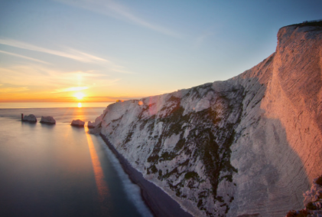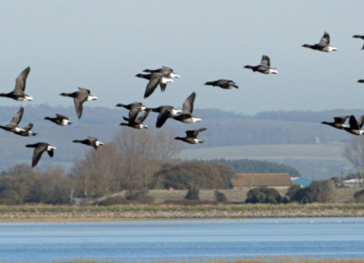
L-R: Dover Castle; The Needles, Isle of Wight; seabirds on the West Sussex coast.

24 November 2023

Celebrating the Year of The Coast 2023, englandscoast.com is the clever tool that offers you the chance to browse over 2,000 coastal businesses – including hotels, B&Bs, self-catering properties, activity and attraction operators, transport companies, restaurants and much more.

The nights may be drawing in, the trees looking barer, and the rain lashing the windows, but there’s never been a cosier time to wrap up in your fleece and waterproofs, lace-up those hiking boots, and prepare for an all-weather break on the coast. Think windswept cliff walks, flasks of hot chocolate on the beach, stargazing on beautifully clear night skies, and tucking into hearty fare and warming red wines and ales by the fireside at a cosy pub.

The south coast offers a plethora of ways to take enjoy the fresh air and seaside this winter, from Dover to Dorset. Explore some of the cosiest options below:

Dark Sky Stargazing on the Isle of Wight
Cut off from the mainland, and a UNESCO Biosphere, the Isle of Wight has very little light pollution and is a perfect destination for stargazers of all ages. Head to some of the island’s more remote locations for the best chance of spotting meteor showers and big displays, take your pick from Freshwater Bay, Compton Bay, Brook Chine, Whale Chine, Culver down, Yaverland and the Needles Headland, and you’ll have the chance to spot The Milky Way, Cassiopeia, Orion and The Plough. For the best experience, plan your night out before or after a new moon; avoid a bright moon as it deflects the light from fainter stars.

Spend a night under the dark skies at one of the Island’s stargazing friendly spots. Choose from a Stargazers Cottage, a converted barn or stay at Tapnell Farm where the Eco Pods take glamping to the next level! From £138 per night in an Eco Pod.in December.

Cliff Walks & Maritime History in Dover & White Cliffs Country
The dramatic white cliffs and windswept beaches of this south-eastern corner are perfect for bracing all-weather walks and holing up in cosy pubs. Take in the majestic views of the White Cliffs of Dover from the hilltop Dover Castle and explore 2,000 years of history and 80 acres of castle grounds, before getting a takeaway hot drink from one of the seafront cafes in Dover such as Mrs Knott’s Tea Room, before walking along the promenade and pier for the best views of the seafront, marina and cliffs. Afterwards, visit Dover Museum and Bronze Age Boat Gallery to see some of the oldest boats in the world and amazing displays of local history.

Explore the quaint and quirky town of Deal, with its independent shops, art galleries, fascinating Deal Castle and pebbly beach dotted with fishing boats and beach huts. The town’s maritime history is a joy to discover, with the Timeball Tower – an iconic Grade II listed building on the seafront which is programmed to drop every day at 1pm – once playing a role in the navy’s coast blockade against smuggling. Take a cobweb-clearing walk along to St Margaret’s Bay, and dine at The Coastguard pub, Britain’s nearest pub to France which has kept watch on the seafront for more than 300 years, with its recently refurbed interiors reflecting its maritime heritage.

Slow Living & Cosy Boltholes in Bournemouth, Christchurch & Poole
The south coast around Dorset offers the ultimate in slow travel, nature and gentle exploration, perfect for a restorative winter break on the coast. Take a daytrip to Brownsea Island, just half a mile from Poole, to discover this beautiful wildlife haven including the rare red squirrel and wide variety of seabirds such as sandwich terns and oystercatchers. There are free electric buggy tours for the less mobile, with all-terrain wheelchairs and pushchairs also available to borrow.

Take in the splendour of Old Harry Rocks at the eastern end of the Jurassic Coast, a series of chalk stacks and stumps that were once time part of a chalk seam stretching from Purbeck to the Isle of Wight. Take a flask of hot chocolate and amble along this stretch of the South West Coast Path, before heading to Studland to hunt for shells and fossils along its beautifully-maintained three National Trust beaches. Retire to The Pig on the Beach, the Studland outpost of the charming country house hotel collection, with its signature shabby chic style and sumptuous kitchen garden restaurant. From £225 per night in December.

In Bournemouth, explore the fascinating Russell-Coates Museum, a collection of curios including pre-Raphaelite art and travel artefacts assembled by two Victorian collectors and travels enthusiasts, housed in a stunning historic house overlooking the sea. Stay at the Green House Hotel , a gorgeous, 32 room boutique hotel that’s run on sustainable principles, from £109 per night.

Wildlife & Walking in West Sussex
The long-stretch of coastline in West Sussex (around 50 miles) is a natural haven, with winter the perfect time for discovering much of the wildlife that lives in or visits this section of coastline. Spot rare and special birds at RSPB Pagham, see water voles in their natural habitat on a boat safari at Arundel Wetland Centre. Or try a Knepp Safari to encounter herds of wild ponies, deer, cattle and pigs as they roam 3,500 acres of Sussex given over to rewilding.

Take in one of the newest sections of the King Charles III England Coast Path which has recently opened between East Head and Shoreham-by-Sea. The new stretch, mainly open coastal plain with long beaches, seaside resorts and nature reserves, opened in October and offers sweeping coastal views, beautiful spots such as Pagham Harbour, and abundant wildlife including Medmerry RSPB Nature Reserve.

For more ideas on all-weather coastal breaks visit englandscoast.com.

-Ends-

Press: For further information, high-res images or to discuss a commissioned press trip, please contact Lizzie Cooper at Travel PR on 020 8891 4440 or l.cooper@travelpr.co.uk.

For more information on England’s Coast visit www.englandscoast.com/en or contact Sheron Crossman, National Coastal Tourism Academy Marketing & Communications: Sheron.crossman@coastaltourismacademy.co.uk.
Notes to editors: The England’s Coast project is delivered by the National Coastal Tourism Academy, whose partners include: Discover Yorkshire Coast, The North York Moors National Park Authority, Visit East Yorkshire, Visit Lancashire, Cumbria Tourism, This is Durham, Enjoy Redcar and Cleveland, Visit North Norfolk, Visit Essex, Visit Thanet, Dover/White Cliffs Country, Visit Brighton, Experience West Sussex, Visit Portsmouth,, Visit Isle of Wight, Coast with the Most -Bournemouth/Christchurch/Poole, Visit Dorset, Destination Plymouth and Hornblower City Cruises Poole
The NCTA was established in 2013 to help job creation and economic growth in the tourism economy of coastal towns. It is a not-for-profit organisation, working with industry, coastal destination partners, government departments, academia and national coastal organisations and is the recognised voice of coastal tourism.

