All Weather Coastal Breaks in Yorkshire, Lancashire & Cumbria with England’s Coast

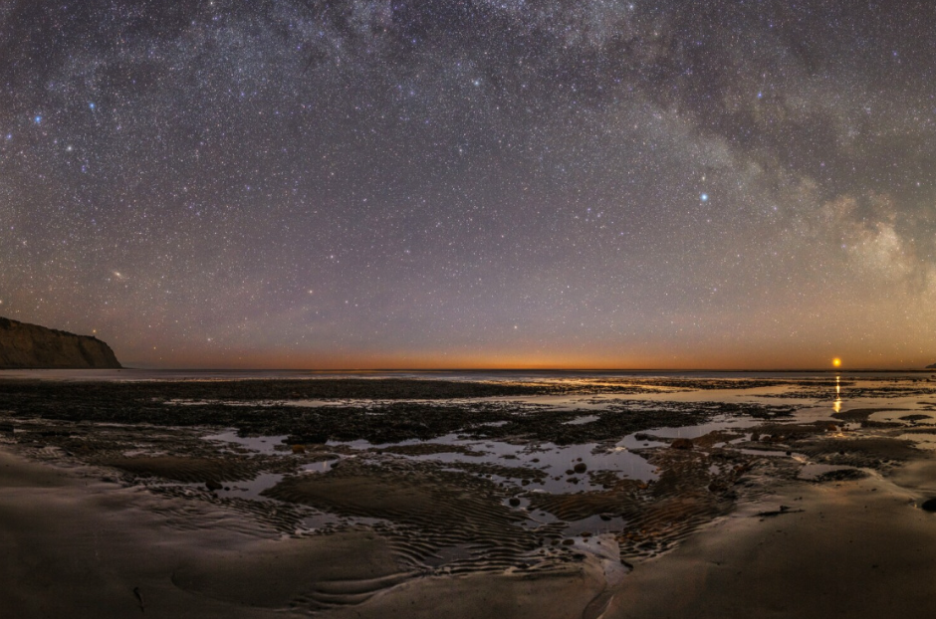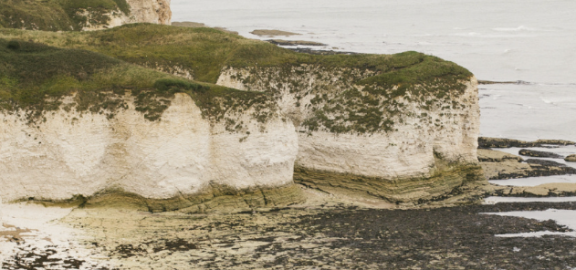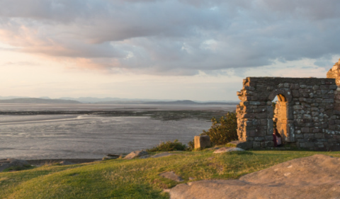
L-R: Dark Skies on the North Yorkshire Coast; Cliffs at Flamborough Head; Morecambe Bay.

24 November 2023

Celebrating the Year of The Coast 2023, englandscoast.com is the clever tool that offers you the chance to browse over 2,000 coastal businesses – including hotels, B&Bs, self-catering properties, activity and attraction operators, transport companies, restaurants and much more.

The nights may be drawing in, the trees looking barer, and the rain lashing the windows, but there’s never been a cosier time to wrap up in your fleece and waterproofs, lace up those hiking boots, and prepare for an all-weather break on the coast. Think windswept cliff walks, flasks of hot chocolate on the beach, stargazing on beautifully clear night skies, and tucking into hearty fare and warming red wines and ales by the fireside at a cosy pub.

The Yorkshire, Lancashire and Cumbria coasts offer a plethora of ways to enjoy the fresh air and seaside this winter, from stargazing to storm watching. Explore some of the cosiest options below:

Dark Sky Stargazing in the North York Moors National Park
With some of the lowest light pollution in the country, the North York Moors National Park is the perfect entry point for Dark Sky gazing. The North York Moors scooped the coveted International Dark Sky Reserve accolade in 2020, one of only 21 in the world, and in the darkest areas of the National Park you can see up to 2,000 stars at any one time. Amazingly the Northern Lights (Aurora Borealis) are also visible from the North York Moors, good displays have recently been seen on the coast. Best bet is to sign up for the AuroraWatchUK app which gives a few hours’ notice. From meteor showers to the Andromeda Galaxy (2.5 million light years away!) and the International Space Station that passes overhead throughout the year – if you want to expand your horizons, have your mind blown by the North York Moors Dark Skies.

While the Dark Skies Festival takes place 9-24 February, you can enjoy the area’s unrivalled stargazing at any time, with winter being an ideal time because of the lack of light pollution. Book a stay-and-gaze package spending a night at a dark skies friendly business who offer telescopes or binoculars, reclining chairs and blankets so you can snuggle down for hours of heavenward gazing, such as The Fox & Hounds in Ainthorpe, from £295 per weekend.

History and Myth in Whitby
Famous for its connections to Bram Stoker’s Dracula, Whitby has always embraced its association with Gothic culture which is reflected in the town’s quirky streets, shops and the Whitby Abbey ruins. This atmospheric town, full of quirks and curios, is the ideal spot for a cosy coastal weekend.

Start off at the Whitby Abbey ruins, sitting majestically on the East Cliff overlooking the North Sea. This seventh century Christian monastery later became a Benedictine abbey and has since then continued to be used by sailors as a landmark at the headland. The Captain Cook Memorial Museum, a 17th century house on Whitby’s harbour, housed the great explorer when he was an apprentice seaman, and the rich collections include many of Cook’s letters, original paintings and drawings from the voyages, ship models and maps, and curious objects from newly discovered lands. In the heart of Whitby Harbour, climb aboard the replica of Captain Cook’s HM Bark Endeavour and dive into her history as a discovery vessel on the high seas with interactive features and displays.

Refuel with food and drink at one of Whitby’s many top notch independent eateries; try the Whitby Brewery Courtyard in the shadow of Whitby Abbey, for Yorkshire ales and sourdough pizza with stupendous views, or award-winning fish & chips by the family-run Quayside.

Rugged Coastal Walks & Birdlife in East Yorkshire
Explore East Yorkshire’s ruggedly beautiful coastline on a clifftop walk from Bempton to Sewerby, taking in the dramatic cliffs at Bempton – home to around half a million seabirds. The coves of Flamborough Head is a Special Area of Conservation, a scenic nature reserve nearby are two ancient lighthouses and the historic town of Bridlington with its wide-open bays. The Filey to Bridlington stretch of the England Coast Path is now open to walkers, with the southern section of the East Yorkshire Coast walk to open in the near future.

Getting Active Along the North West Coast
The North West coast offers so many opportunities to get active in the colder months. Explore the region on two wheels via the spectacular 81-mile Bay Cycleway, which starts on Walney Island near Barrow, taking riders through the Arnside & Silverdale Area of Outstanding Natural Beauty. The relatively flat route hugs the spectacular coastline of Morecambe Bay along quiet roads, greenways, canal towpaths and promenades – great family fun! Move along at your own pace, stopping off for incredible views and hearty food and drinks at welcoming pubs en route.

Get back to nature on the North West coast with a visit to one of the many nature reserves and Areas of Outstanding Natural Beauty, including Walney Island which is home to two nature reserves, spot wild fallow deer at Holker Hall and Gardens, or spy seabirds at St Bees Cliffs, home to an RSPB reserve with one of the largest seabird colonies on the west coast of England.

For more ideas on all-weather coastal breaks visit englandscoast.com.

-Ends-

Press: For further information, high-res images or to discuss a commissioned press trip, please contact Lizzie Cooper at Travel PR on 020 8891 4440 or l.cooper@travelpr.co.uk.

For more information on England’s Coast visit www.englandscoast.com/en or contact Sheron Crossman, National Coastal Tourism Academy Marketing & Communications: Sheron.crossman@coastaltourismacademy.co.uk.
Notes to editors: The England’s Coast project is delivered by the National Coastal Tourism Academy, whose partners include: Discover Yorkshire Coast, The North York Moors National Park Authority, Visit East Yorkshire, Visit Lancashire, Cumbria Tourism, This is Durham, Enjoy Redcar and Cleveland, Visit North Norfolk, Visit Essex, Visit Thanet, Dover/White Cliffs Country, Visit Brighton, Experience West Sussex, Visit Portsmouth, Discover Gosport, Visit Isle of Wight, Coast with the Most -Bournemouth/Christchurch/Poole, Visit Dorset, Destination Plymouth and Hornblower City Cruises Poole
The NCTA was established in 2013 to help job creation and economic growth in the tourism economy of coastal towns. It is a not-for-profit organisation, working with industry, coastal destination partners, government departments, academia and national coastal organisations and is the recognised voice of coastal tourism.

